Assignment

1. Use the who command and redirect the result to a file called myfile1. Use the more command to see the contents of myfile1.

Solve:

Step – 01: When i use  , then system create a file like-- 

Step – 02: Next use command  and we can see the content of “myfile1” like ---  .

Comment:

* Command “who>myfile1” create myfile1. If the file "myfile1" already exists, the old version will be overwritten and content redirect the result to “myfile1”.
* Command “more myfile1” shows the content on terminal from “myfile1”.

1. Use the date and who commands in sequence (in one line) such that the output of date will display on the screen and the output of who will be redirected to a file called myfile2. Use the more command to check the contents of myfile2.

Solve:

Step-01: Command “date; who>myfile2” shows the output of “date” and the output of who redirected to a file myfile2.

Input command: 

Output: 

Step-02: Next command “more myfile2” and

Output: 

Comment:

* Command “ date” provide the system date. Then using “who>myfile2” redirect the result to “myfile2” and finally “more myfile2” display the content of myfile2.

1. Write a sed command that swaps the first and second words in each line in a file.

Solve:

Step-01: At first we have to take a file which contains some lines and if we use command like -- 

Then output will be-- 

Comment:

* where "-e" comes multiple times as "-e" is to be used to apply multiple commands on the input. Like—

sed -e 's/a/A/g' -e 's/b/B/g' 1.txt

a with A  
 and  
 b with B  
 hence two "-e" are used.

* Here the "s" specifies the substitution operation.
* The "\(" and "\)" operators will save whatever is found between them.
* \1 indicates the first pattern and \2 indicates the second pattern.
* “-e” is optional,  provides the same output like above.

1. Write a (i) shell script program and (ii) C program to display “HELLO WORLD"

* Compare the running time of both the programs using time command.

Solve:

(i)

Step_01: Now we need to write a shell script program, like-- 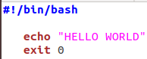

Here use command “time sh four_a.sh” and our desired output will be-

And 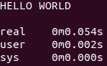

(ii)

Step-01: We have written a c program and use command 

Which execute the four_b.c program.

Secondly use command  to display the output like- 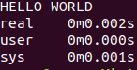

Comment:

* The above process was simple task which I discuss above briefly.

1. Write a shell script that takes a command --line argument and reports on whether it is directory, a file, or something else.

Solve:

Step-01: Here I create a file like five.sh 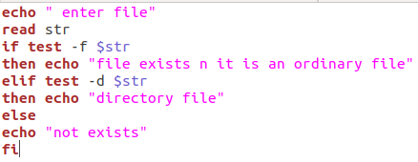

Now

--read str implies that take a file name with type.

---test is used as part of the conditional execution of shell commands.

--- -d file implies file exists and is a directory.

--- -f file implies file exists and is a regular or ordinary file.

Input & Output: 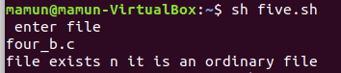

1. Write a shell script that accepts one or more file name as arguments and

converts all of them to uppercase, provided they exist in the current di-rectory.

Solve:

Step—01: First of all, i take file , system check is it valid file. If valid then, convert into upper case. Like---

Code: 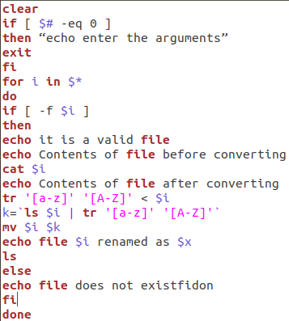

-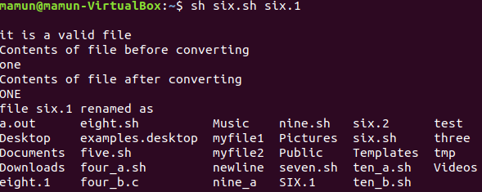

1. Write a shell script that determines the period for which a specified user is working on the system.

Solve:

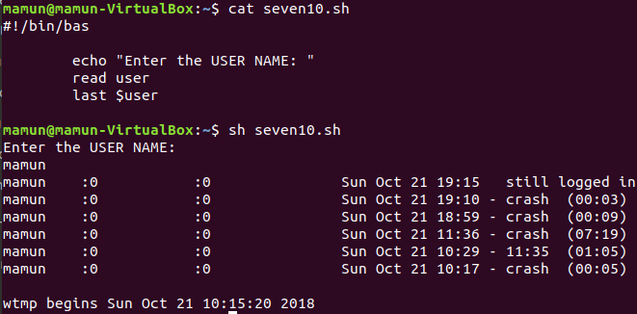

Or,

Step-01: Here i create a seven.sh file like----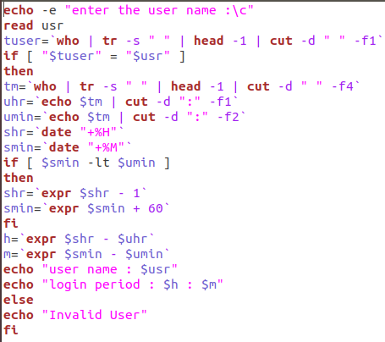

In command line: 

Output: 

Comment:

--- read user implies the user name as input.

--- tuser return the sustem user and if condition check two user is uqual or not.

1. Write a shell script that accepts a file name, starting and ending line

numbers as arguments and displays all the lines between the given line

numbers.

Solve:

Step—01: Here we need to give file name, starting and ending line number which provide all the lines between the given line numbers.Like--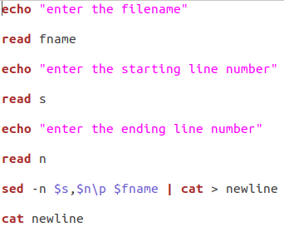

Input: 

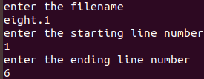

Output:



Comment:

* -n $s, $n\p $fname implies to detect the line should be displayed between starting and ending number. And through the result to file newline. 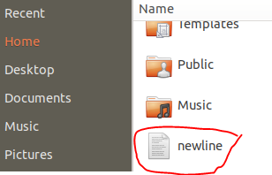

1. Write a shell script that deletes all lines containing a specified word in one

or more files supplied as arguments to it.

Solve:

Step--01: The shell script program is-----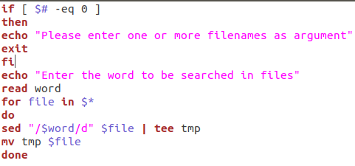

Step—02: We check this using command

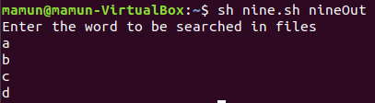

//nineOut is a file to be searched.

Comment:

* Firstly it take a file which need to be search.
* Secondly take a character and use a for loop to do so.

10. Write a shell script to perform the following string operations:

(a) To extract a sub-string from a given string

(b) To find the length of a given string

Solve:

(a)

Step-01: Now we have to extract a sub string from a given string.

Code:

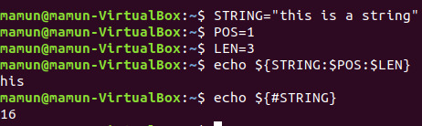

Output: his

(b).

Step—01: Here we enter the script program using bash and take a string and give the length like ${#var};

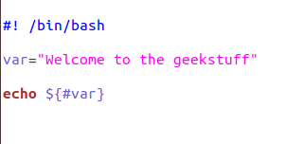

Command line input: 

Output: 